5.5.2 Integration by Substitution (Definite Integrals)

Theorem: If is continuous on and f is continuous on the range of , then

Note: We see from the above theorem that we have to worry about changing the bounds when it comes to performing a u-substitution on definite integrals.

Example 1: Find .
We note is continuous on so we can use FTCP2.
Let and thus
Our limits of integration become: and
Therefore,

Note: There are some differences between the u-substitutions in indefinite integrals and definite integrals that are worth noting. For indefinite integrals we always have to plug our original variable of integration back in for u after the integration is complete, and we need to remember to add a constant to our antiderivative.
On the other hand, for definite integrals we need to change the bounds, but we will NEVER plug back in for our original variable of integration after changing the bounds, and we need not add a constant to our antiderivative since any antiderivative will give the correct value of the definite integral by the FTCP2.

Example 2: Find
We note is continuous on so we can use FTCP2.
Let and thus
Our limits of integration become: and
Example 3: Determine each of the following.
- Find .
We note is continuous on so we can use FTCP2.
Let and thus
Our limits of integration become: and
Therefore,

- Find
We note is continuous on so we can use FTCP2.
Let and thus
Our limits of integration become: and
Therefore,

- Find
We note is continuous on so we can use FTCP2. Also .
Let and thus
Our limits of integration become: and
Therefore,

Symmetry & Integrals
Theorem (Integrals of Symmetric Functions):
Suppose f is continuous on .
- If f is even , then .
- If f is odd , then .

General Idea: Consider the two following example functions which illustrate the above theorem.
Even:  We now this function is even because  We then see that . | Odd:  We now this function is odd because  We then see that .
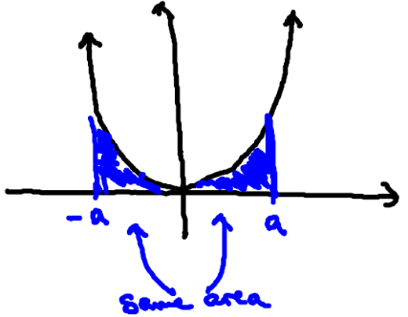 | 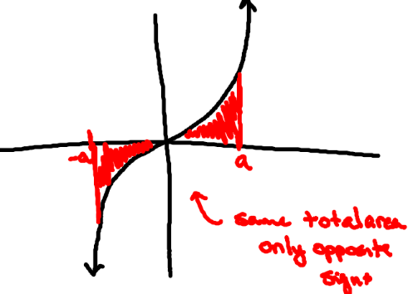
Proof :
We first note that
We perform a substitution on the integral .
Let , then and .
Our limits of integration become: and
Therefore we can say that .
So we have that .
- If f is even then
- If f is odd then

Example 4: Find .

We first notice that continuous on so we can use the FTCP2.
We also see that f is an even function because:

Therefore we compute

Note: This integral could have still be evaluated without making use of the fact that was an even function. However, at times evaluating integrals in this way can be easier since one of the limits of integration becomes 0.

Example 5: Find .
We note that is continuous on the interval so we can use the FTCP2.

We also see that f is an odd function because:
Therefore we compute.

Note: We can see that being able to determine that a function is odd can make the evaluation of certain integrals extremely easy.

